**RIPHAH INTERNATIONAL UNIVERSITY, ISLAMABAD**



**Lab # 6**

**Bachelors of Computer Science – 6th Semester**

**Subject: Operating System**

**Submitted to: Ms. Kausar**

**Submitted by: Nimra Ashfaq-40852**

**Date of Submission: 16- Sep -2024**

**QUESTION:1**

1. The time of the log entry in the 12-hour format with AM/PM.



2.The date of the log entry in the "Month Day Year" format.



3.The full weekday name for the log entry.



4.The numerical representation of the month.



5.The last two digits of the year.



**QUESTION: 2**

What command would you use to display the current time in a 24-hour format with only hours and minutes?



**QUESTION: 3**

What is the command to get the current year in four-digit format



**QUESTION: 4**

How can you get the current date in a combined format of numerical day, month, and year and Time?



**QUESTION: 5**

You need to determine the date of the previous day from today. Write the command that you would use to get yesterday's date.



**QUESTION: 6**

You are preparing a schedule and need to find out the date for the following day. What command should you use to display tomorrow's date?



**QUESTION: 7**

Suppose you are working on a report that needs to include the date exactly 10 days before today. Which command will help you find this date?



**QUESTION: 8**

You need to quickly view the calendar for the current month to check upcoming events. What is the command to display the calendar for the current month?

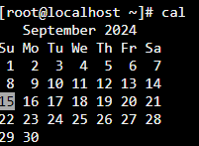

**QUESTION: 9**

**Y**ou are organizing a historical review and need to view the calendar for May 2024. Write the command that will show the calendar for this specific month and year.

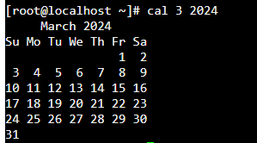

**QUESTION: 10**

You are creating a simple shell script to automate a routine task for your team. The script needs to display a series of important messages to the user, and then it should clear the terminal screen to prepare for the next set of instructions.

First, you want to print a welcoming message that includes the current date and time. Use the echo command for this purpose.



After displaying the welcoming message, the screen should be cleared to keep the terminal uncluttered before moving on to the next part of the script.



**QUESTION: 11**

You have a file named data.txt containing a list of strings, one per line. How would you sort these strings in reverse alphabetical order?

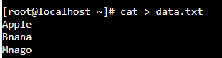

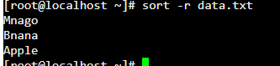

**(B)** You have a file named records.txt where each line contains several fields separated by spaces. How would you sort this file based on the values in the second column?

